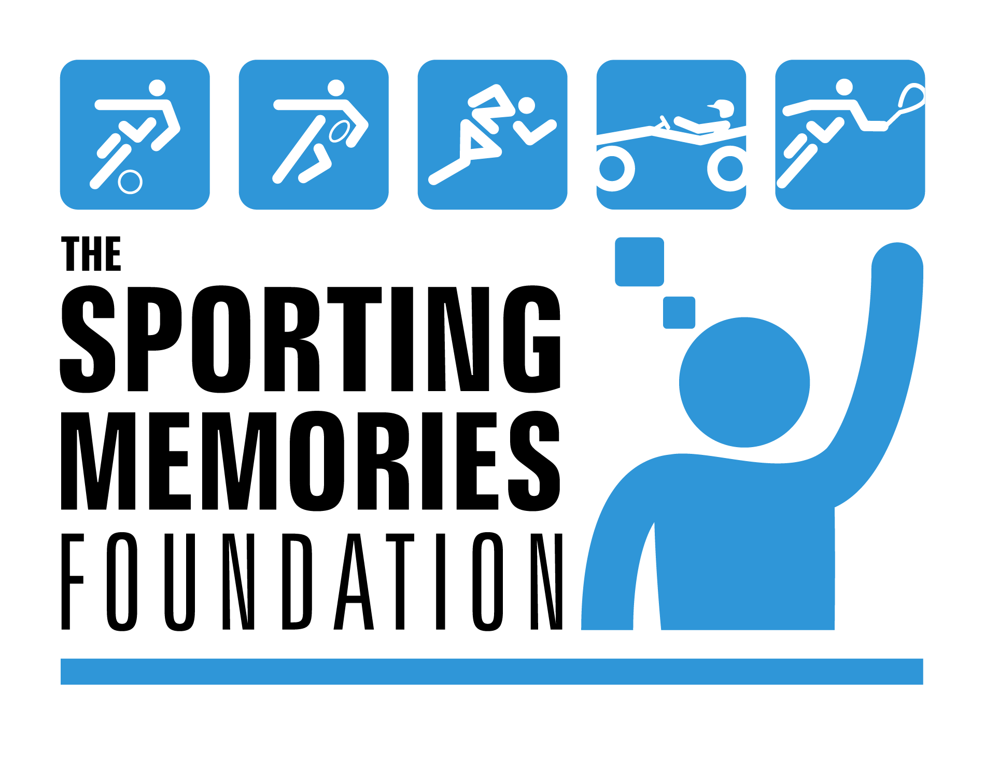

Communications Assistant (Social Media)
6 months fixed-term with view to extending
25 hours per week
£16,000 full-time equivalent
Working from home or your own office space, based in the Edinburgh area

This is a brand new role within our organisation and an opportunity to make your mark on the communications reach and engagement of a UK charity. Reporting to and working closely with our Communications Manager, in this role you will engage with some of the biggest accounts and personalities of the sporting and media world, and with those people and organisations who lie at the heart of our work.

We use the power of talking about and remembering sport to tackle dementia, depression and loneliness among older people. While social media is just one part of our overall strategy, it is an aspect we strive to use in the most effective way possible.

Using your love of social channels, communicating and relevant experience, you will help to shape, support and grow our reach at a time when this is needed more than ever.

The role and about you
It goes without saying that you will enjoy sport. In fact, it will be pretty much a passion. A love of talking all things sport.

You will enjoy following big personalities and organisations in sports and sports media. You will understand how to make meaningful connections and have the confidence to engage, with guidance, with some of the biggest social media accounts in the sporting world.

Crucial is an understanding of our core work: to engage with members of the public; with older people who may be living with dementia, loneliness or depression, their families and their carers; our volunteers current and potential; and with our stakeholder organisations.

Your focus will be on providing social media support and input, but there will be opportunities to provide communications support across a range of tasks, such as collating quotes and case studies, writing news articles, supporting campaigns and building contact and media lists.

We don’t expect you to have run huge social media accounts or campaigns, but you will be able to demonstrate and provide examples of a true interest in engaging and building a variety of audiences across Twitter, Facebook, LinkedIn and Instagram – using a wide range of imaginative and effective targeted strategies. This could be through employment or your studies, own work or interests.

Key to your role will be social media planning. Your focus will be on our Central, Scotland and Wales accounts, but you will also support and provide recommendations for our regional accounts (for example, Manchester and South East England).

Analytics are important. But not just ‘pulling them off’ – you need to be able to use them to drive consistent growth and engagement across our core channels, with the right people at the right times on the right platforms.

With support from our Communications Manager, including guidance from a recent review of our social media, you will come to understand how our organisation’s strategies and policies, and those of others, influence day by day how we run our channels. With guidance you will be able to contribute sensitively and thoughtfully.

Your written English will be perfect. Imaginative. Engaging. Accessible. And take into account our audiences and their different needs. You will be able to digest policy information alongside the latest scores.

Ideally you will have experience of using a website content management system. We would like you to be confident in using Office 365, including SharePoint and Teams. We would also like you to have the skills necessary for basic video and sound-clip editing.

We would like you to have had experience of volunteering for a social enterprise or charitable organisation – or to be able to demonstrate where your own work has made a positive difference to the lives of others.

You will be able to work efficiently from home or your office space but really enjoy being part of a team and contributing to our task groups. We love getting together for a ‘virtual’ coffee and to talk about sport just as much as our Club members do!

Once the relevant coronavirus restrictions are lifted, we are hopeful there will be opportunities for in-person meetings and collaboration in Edinburgh.

Salary and hours
Hours: 25 hours per week, fixed term for 6 months and there may be an opportunity to extend thereafter.

While flexible working is welcomed, you must generally be available to attend weekday online meetings and maintain consistent days. Short periods of weekend or evening work are inevitable from time to time, as our social media channels can be busiest at these times, often coinciding with sporting events.

Salary: £16,000 full-time equivalent

Holidays: 25 days plus 10 bank holidays, pro rata

Start date: By arrangement, with an opportunity for an immediate start following formal acceptance of the role.

How to apply
Please send the following via email to our Communications Manager Helen Johnston at helen@thesmf.co.uk by 5pm on Monday 22 March:
– A covering letter that shows us why Sporting Memories and our mission means so much to you
– Your CV to show us your relevant experience and interests
– Descriptions of two social media campaigns or targets you have been involved with, demonstrating growth in engagement, an analysis of effectiveness, and strategic content for different channels and audiences
Successful applicants will be invited to an online interview that will take place on 25 March.

